One-day Tour <Sunday, August 30, 2026>

Lugano, Bellagio, Lake Como and Como Day Tour

Experience the beauty of Italy and Switzerland on a day trip from Milan. Cruise past celebrity villas on Lake Como, stroll through charming Bellagio, and cross into Switzerland to explore Lugano with free time for lakeside views or chocolate shopping.

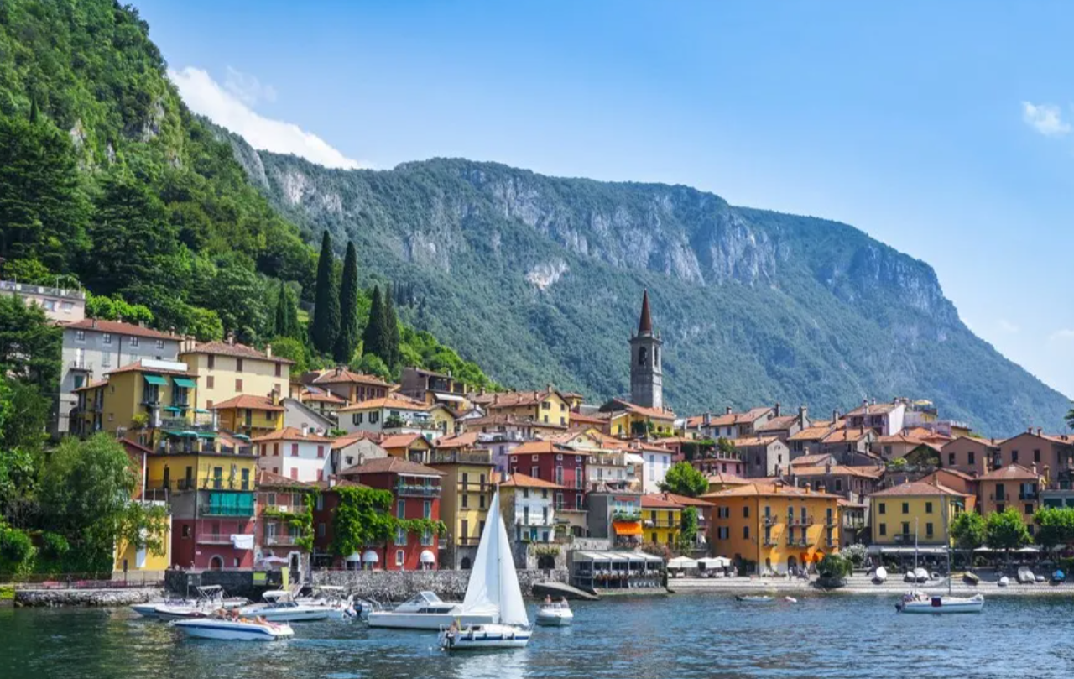 | 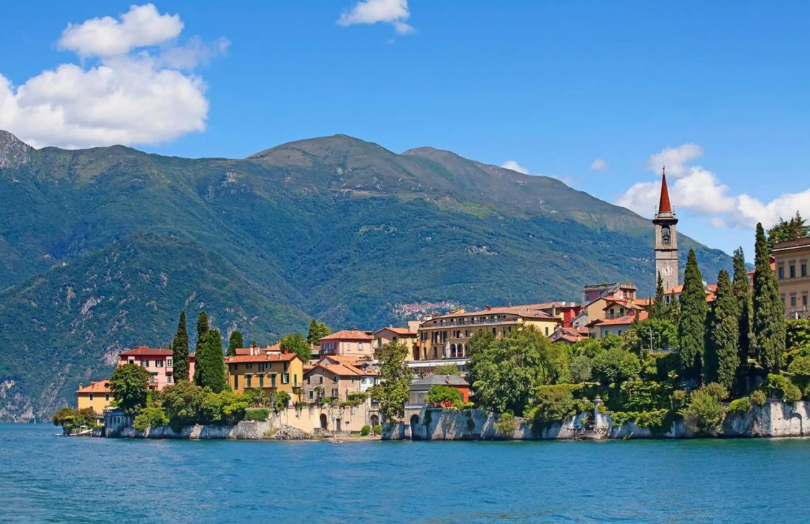
 | 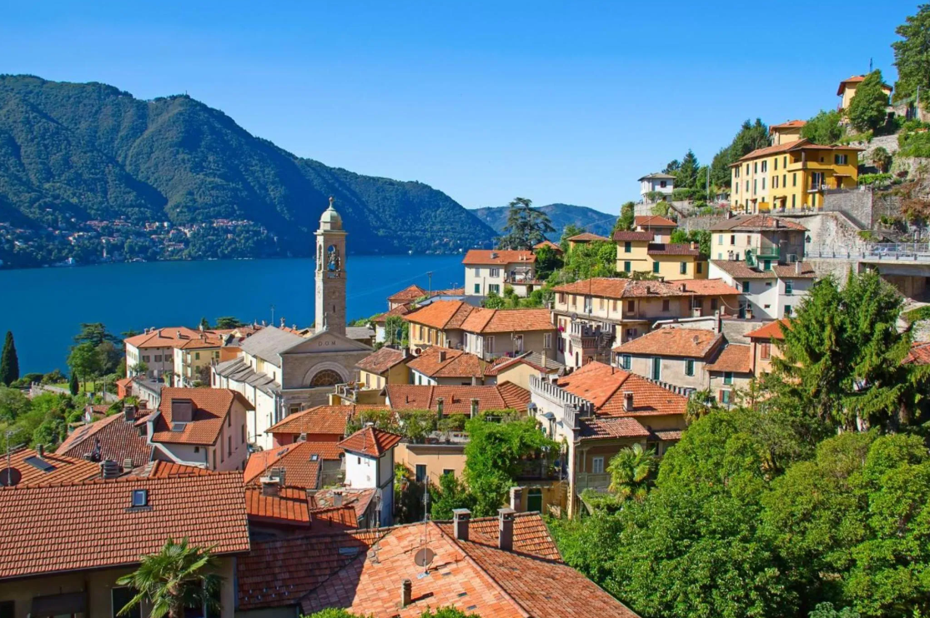
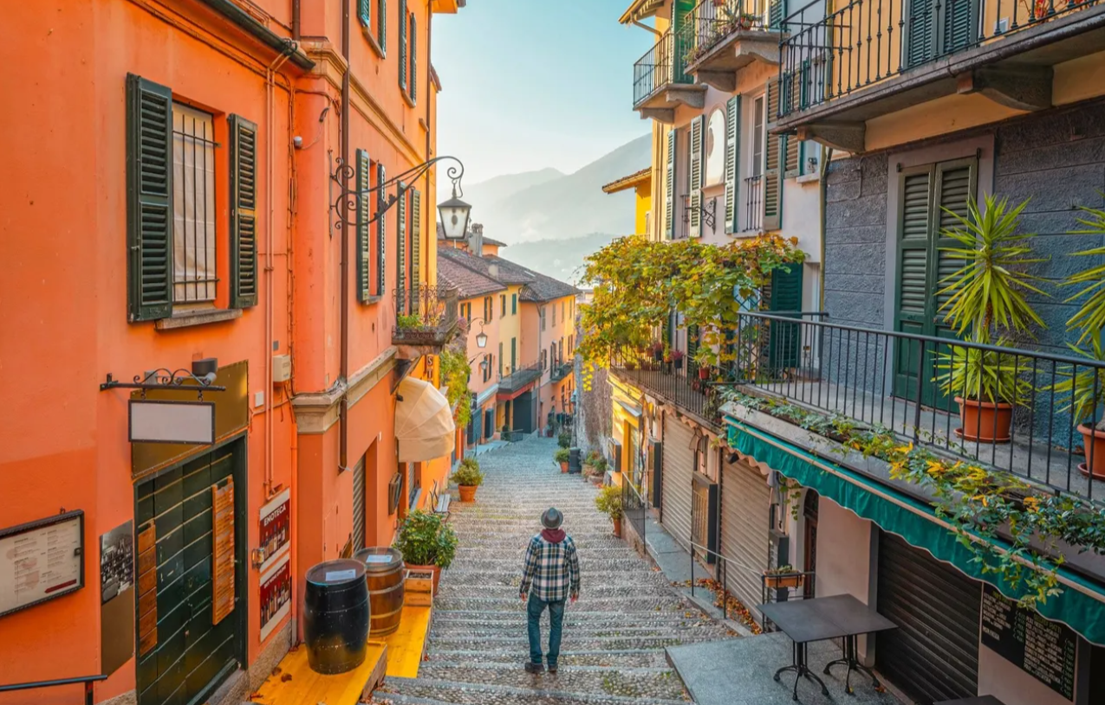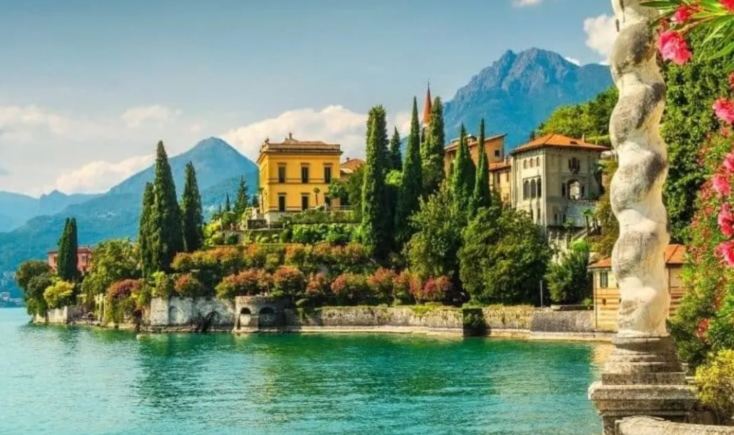
Activity Overview

Depart from Milan on a full-day guided tour to explore two countries in one day: Italy and Switzerland. This day trip takes you to the world-renowned Lake Como, the charming village of Bellagio (known as the "Pearl of Lake Como"), the elegant Swiss city of Lugano, and the historic town of Como. Enjoy an exclusive private panoramic boat cruise on Lake Como, stroll through colorful cobblestone streets, taste authentic Swiss chocolate, and admire stunning Alpine and lakeside scenery.

Key Highlights

- Visit two countries in a single day – Italy and Switzerland.
- Take a luxurious private panoramic boat tour of Lake Como, passing iconic villas such as Villa del Balbianello and Villa Balbiano.
- Explore Bellagio, the "Pearl of Lake Como," with its charming stair alleys, cobblestone streets, quaint shops, cafes, and historic architecture.
- Discover Lugano’s city center, stroll along the palm-fringed lakeside promenade, and sample renowned Swiss chocolate.
- Enjoy a guided walking tour of Como, including its Gothic cathedral (Duomo di Como) and historic landmarks.
- Capture breathtaking Instagram-worthy photos of Lake Como and the surrounding Alps.

Itinerary

08:00 Depature from <Conference Hotel>
10 hour(s) Guided tour
Lugano ➡ Bellagio ➡ Lake Como ➡ Como
18:45 Return
* The schedule might change depending on traffic and weather conditions

Important Note:
Please arrive at the location 15 mins before the departure time.
Latecomers or no-shows can't be refunded.
A valid passport is required to enter Switzerland
Free time for lunch in Bellagio (lunch is at your own expense).
Comfortable walking shoes recommended (cobblestone streets and stair alleys).

✅ What's included:
- English / Spanish-speaking guide
- Round-trip transfers to and from the meet up location
- Audio radio
- Travel in comfort by luxury air-conditioned coach or bus
- 45-minute luxurious private boat tour on Lake Como
X Hotel pick up and drop off
X Meals and beverages
X Other personal expenses
X Tips and gratuities

📅 Registration deadline: August 20, 2026, 5:00 PM UTC+2 (Central European Summer Time)
📩 Please send the filled registration form to your conference secretary.
Tour Registration
One day Tour | 150 USD / Person
Online Payment Link | https://confsys.iconf.org/awxpay
E-mail: | Order ID:
Name: | Tel. or WhatsApp:

